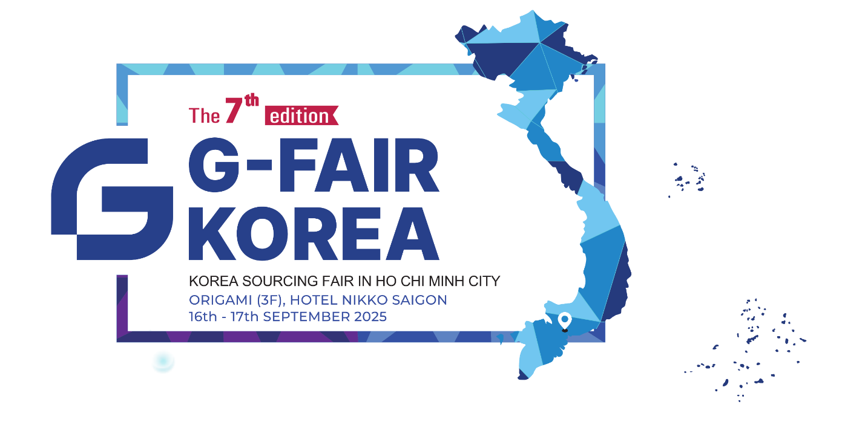





Consumer Products
&
Food
Industrial
&
Medical Products
Beauty & Health
Electronics
&
Electrical Productsa

Dear .

We are pleased to invite you to attend

“G-Fair Ho Chi Minh 2025 – Korean Product Trade Fair in Ho Chi Minh City”

DATE &TIME
Time: 09:00 AM – 05:00 PM
Date: 16th - 17th September, 2025

VENUE
Hotel Nikko Saigon
3rd Floor, Origami Ballroom
235 Nguyen Van Cu, Cau Ong Lanh Ward, HCMC
Tel: 028-3925-7777
EXHIBIT ITEMS
- Zone A: Consumer Products & Food
- Zone B: Industrial & Medical Products
- Zone C: Electronics & Electrical Products
- Zone D: Beauty & Health

Sincerely,
Kim Dong Yeong
Director & CEO
GBC Ho Chi Minh
(S&H Business Solutions Co., Ltd.)

ORGANIZER
Cong Ty TNHH MTV Son Phat
Gyeonggi Business Center Ho Chi Minh
(Cong Ty TNHH Giai Phap Kinh Doanh S&H)
Gyeonggido Business & Science Accelerator

BUSINESS OPPORTUNITIES
Direct exchange with Korean companies
Access to a wide variety of products
Opportunity to become an exclusive distributor in Vietnam
Free admission

CONTACT INFORMATION
Manager & PIC Name:
E-mail:
Office:
Mobile:
Code Number:

REGISTER ONLINE
https://forms.gle/mz79GX4PofgQgjyr7

